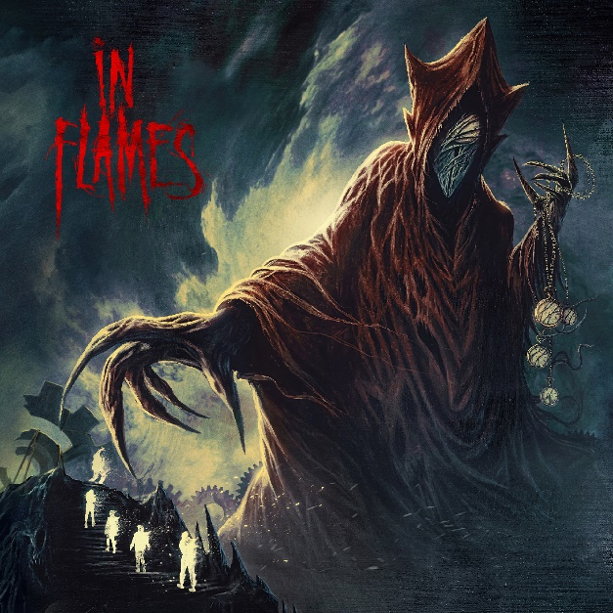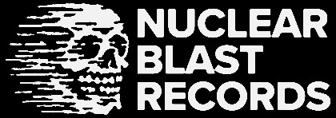

**IN FLAMES**

***Foregone***

##### Release Date: February, 10th 2022

|  |  |
| --- | --- |
| **Line up:** | **IN FLAMES online:** |
| Anders Fridén – Vocals  Björn Gelotte – Guitar  Chris Broderick – Guitar  Bryce Paul – Bass  Tanner Wayne – Drums | <https://www.inflames.com/>  <https://www.youtube.com/@InFlames>  <https://www.instagram.com/inflames/>  <https://twitter.com/InFlames_SWE> |
|  |  |

**IN FLAMES** represent the best of metal’s past, present, and future. New Wave Of Swedish Death Metal architects and innovative purveyors of groove, hard rock, and melody, the band’s artistry, influence, and stature loom as large as the vibrant style’s horizons. The widely recognized titans boast an impressive and diverse catalog celebrated internationally. **IN FLAMES** are as vital (and even more energized) today than when they unleashed classics like ***Come Clarity*** and ***Clayman*** in decades past.

*“IN FLAMES are one of the few bands to successfully pull off a radical stylistic shift and not only maintain but actually grow their fan base, while also staying true to the band’s core sense of self,”* Revolver Magazine wrote in 2020, saluting their dual status as hooky hard rock heroes and melodeath icons.

The continued popularity of anthems like ‘Only for the Weak’ (72 million streams on Spotify alone), ‘Cloud Connected,’ ‘Alias,’ ‘I Am Above,’ ‘Pinball Map,’ ‘Zombie Inc.,’ ‘Artifacts of the Black Rain,’ and ‘Come Clarity’ demonstrates how much the fans embrace the diversity of **In Flames**.

The songwriting duo of singer **Anders Fridén** and guitarist **Björn Gelotte** (both of whom appear on every **IN FLAMES** release since 1995) persists as one of the most potent creative teams in heavy music.

***Foregone***, the furious fourteenth studio album, combines the greatest aggressive, metallic, and melodic strengths of their landmark records with the seasoned songwriting of their postmodern era.

*“In a way, it sounds stupid to say we wanted to be more ‘metal,’ because we always felt that we were,”* **Fridén** observes. *“Over the last couple of years, the world became even more hostile and evil in certain ways. We have a war in Europe. People, in general, are more stressed. All of that energy and anger helped fuel this album. We went in to make something on point, heavier, and yes, ‘more metal.’”*

**Gelotte** concurs. *“We made an aggressive album. We kept the dynamics, some big epic choruses, heavy guitars, lots of kick drums, and melodies. That’s who we are and who we’ve always been.”*

***Foregone*** is the second **IN FLAMES** album with bassist **Bryce Paul** and drummer **Tanner Wayne**, the first with ex-MEGADETH guitarist **Chris Broderick**, and the third with Grammy-winning producer **Howard Benson** (MY CHEMICAL ROMANCE, THREE DAYS GRACE). **Mike Plotnikoff** (ALL THAT REMAINS, WARBRINGER) engineered at Benson’s West Valley Recording Studios. **Joe Rickard** (10 YEARS, STARSET, DIAMANTE), who played drums for **IN FLAMES** from 2016 through 2019, handled mixing duties.

*“Tanner is the best drummer we’ve ever had*,” **Fridén** says proudly. *“I don’t say that to diss anyone that came before. Tanner has so much energy and there is so much stuff going on all of the time. Bryce is an amazing bass player, really, really heavy, with a good feel. Chris comes in with all of his knowledge of the guitar. His solos are way different from Bjorn’s and the combination of those two guys just works perfectly. It’s easy to do what I do on top of it because the foundation is so solid.”*

Songs like ‘State of Slow Decay,’ ‘End the Transmission,’ ‘Bleeding Out,’ ‘Meet Your Maker,’ and ‘The Great Deceiver’ pulsate with hypnotizing power and furious anger. There’s desperation, a raw nerve exposed, brought on by the chaotic dystopia of post-pandemic society.

*“This album is about lost time. Everything is going in the wrong direction,”* **Fridén** explains. *“We can’t make up for the lost time. That’s why the album is called Foregone. We’re destined to end. That realization creates different emotions – panic, frustration, fear. ‘Scary’ isn’t a horror movie or an angry metal guy screaming. The real horror is what’s going on in the news from around the world. We are basically doomed. The album is about the few moments we have left and what we do with them.”*

The melodic guitars, crushing riffs, and high-speed tempos that define much of the **IN FLAMES** catalog first crystalized on their second album, ***The Jester Race*** (1996), complete with hints of the catchy choruses to come. ***Whoracle*** (1997) is the rawest and arguably heaviest **IN FLAMES** album from the 90s.

Metal Hammer declared melodeath masterpiece ***Colony*** (1999) *“an undisputed fireball of an album.”* ***Clayman*** (2000) introduced synths and more prominent clean vocals, with accessible hooks, without sacrificing the band’s overall intensity, resulting in their first Top 20 album in Sweden. ***Reroute to Remain*** (2002) took the groove element even further and broadened the American audience.

***Soundtrack to Your Escape*** (2004) expanded the arena rock bombast. ***Come Clarity*** (2006) is a perfect metalcore slab, as majestic as the American bands **IN FLAMES** inspired. Even as it stepped away from death metal, ***A Sense of Purpose*** (2008) delivered some of the band’s best and most eclectic songs.

The gothic groove metal of ***Sounds of a Playground Fading*** (2011) paved the way for the unapologetic arena rock of ***Siren Charms*** (2014) and ***Battles*** (2016), albums full of Active Rock hooks. Fans of the more aggressive side of **IN FLAMES** heralded ***I, the Mask*** (2019) as a return to form. ***Foregone*** masterfully, if improbably, manages to serve all sides of the **IN FLAMES** fanbase, with powerful force.

*“We’ve had our fair share of times when we were trying to please others,”* **Fridén** reflects. *“‘You should write with other people. You should go after radio.’ We tried it but it wasn’t for us. With this album, we didn’t even think about anyone else or any of that.”* The major strength of ***Foregone***, and of **IN FLAMES** altogether, continues to lie in the long partnership between the singer and guitarist.

*“Bjorn and I have 100 percent trust in each other,”* **Fridén** says. *“He can give me a piece of music and know that I will give him something back he’ll feel proud about. I know his way of playing and it’s something I love singing on. He’s from that Ritchie Blackmore, Jimmy Page school of soulful, bluesy guitar players. And he has a good melodic sense. I know him inside and out and I love him to death.”*

Both men continue to follow their own compass*. “It’s impossible to please everybody. So the most important question to ask is always, ‘Do we like it?’”* **Gelotte** points out. *“If I didn’t like the music we play, I couldn’t believe in it. It’s a lot of time away from family. I wouldn’t do this if I didn’t love it. That’s why we’ve been able to do it for such a long time; because we actually enjoy what we do.”*

The band built a stunning reputation with devastating, crowd-moving, inspired performances around the world at every major rock and metal festival imaginable, on festival tours like Rockstar Mayhem and Ozzfest, headlining multiple treks, and touring with their heroes, friends, and giants in the genre.

The band regularly headlines some of the biggest stages and festivals in the world. The list of **IN FLAMES** tourmates boasts SLIPKNOT, MEGADETH, JUDAS PRIEST, KILLSWITCH ENGAGE, WITHIN TEMPTATION, and LAMB OF GOD. (Over the years, they even took newer bands like GHOST & GOJIRA as support acts.)

“I’m really proud of what we achieved and that we never went away,” **Fridén** says reflectively. *“Sometimes you’re loved, sometimes you’re not, but we always pushed ourselves and created the music we felt was awesome. I’m so proud and happy with Bryce, Tanner, and Chris, what they’ve brought into the band, on the recordings, and with their energy, and where IN FLAMES is at today.”*

A sense of pride, accomplishment, and continued vitality are evident every time the band takes the stage, and all over ***Foregone***. The album itself represents **IN FLAMES** of the past, present, and future.

*“Not caring about anybody’s opinion but ours is a great situation to be in,”* **Gelotte** says. *“We’re confident in what we’ve done. We love what we’re doing. And we’re constantly exploring forward.”*